Productive Value-Productive Power in a Dynamic Multi-Agent Productive System
The Asterion Benchmark V2
Publication Candidate v0.6 — Statistical-Conformance and Editorial Pass — 2 September 2026

Abstract
Decision architectures for productive systems must operate under heterogeneous capacities, commitments, resource dependencies, delayed quality effects, finance constraints, incomplete information, and stochastic disturbance. This paper introduces Asterion Benchmark V2, a dynamic multi-agent productive-system benchmark used to compare a frozen Productive Value-Productive Power (PV-PP) controller with a family of constrained scalar controllers and a local deterministic/priority comparator. The primary M14 ensemble contains 1,000 frozen common-random-number seeds and seven regimes per seed, yielding 7,000 regime-runs. Across the principal paired comparison with the balanced scalar controller B0, PV-PP produced a mean 185.6 additional delivered usable units, 178.4 fewer physical-shortage unit-weeks, $380.6 thousand greater terminal manufacturer cash, $71.3 thousand lower adaptation expenditure, and substantially higher terminal supplier line and quality productive power. The paired differences were directionally consistent across nearly all seeds. These results establish strong empirical separation within the frozen Asterion benchmark; they do not establish universal superiority over scalar or deterministic control.

1. Introduction
Many economic and operational decisions are described as choices among alternatives under multiple objectives and constraints. A harder problem arises when the object being governed is itself a productive system: today's decision changes not only current output or cost, but also the capacities, relationships, qualifications, reserves, information states, and commitments from which future production must be generated.
Asterion Benchmark V2 was constructed to stress that distinction. It models a small but tightly coupled industrial system in which a focal manufacturer depends on suppliers, a customer, finance, logistics, and certification processes. Productive capacities persist through time and can deteriorate, recover, become encumbered, or become unusable. Quality failures may be latent and appear only after delivery. Contractual and financing choices alter later feasibility. Agents act with bounded information rather than oracle access.
The governing research question is whether the frozen Productive Value-Productive Power (PV-PP) architecture can maintain coherent productive-system behavior in this environment, and how its behavior differs from specified scalar and local deterministic comparators operating over the same licensed world and action surface. The benchmark is not designed around a single global score. Outcomes remain in their native dimensions so that delivery, shortage, cash, adaptation expenditure, quality events, collapse, and named productive-power domains remain separately visible.
The primary evidentiary run reported here is M14. It follows earlier benchmark builds used to identify and correct specification and implementation defects. Those corrections were made prospectively from frozen benchmark authority or explicit outcome-blind closure; earlier runs were preserved rather than overwritten. M14 was then executed as a fresh 1,000-seed, seven-regime ensemble and banked only after conformance, structural, provenance, common-random-number, and replay audits.
The paper's contribution is consequently benchmark-specific and architectural: it asks whether a frozen PV-PP controller behaves differently from specified competent alternatives in a productive system where persistent capacity, quality, contracts, finance, qualification, information, and downstream viability coevolve. It does not claim that PV-PP is the first non-scalar, constrained, risk-aware, or receding-horizon decision method.
Finally, Asterion's experimental discipline follows established simulation and empirical-design concerns. Common random numbers compare alternatives under shared stochastic inputs, while modern benchmark methodology emphasizes implementation sensitivity, statistical uncertainty, baseline construction, and experimenter bias (Kleijnen, 1988; Patterson et al., 2024). M14's event-keyed CRN discipline, paired seed analysis, frozen comparator family, preserved diagnostic builds, and post-run audits are therefore central methodological controls rather than ancillary engineering details.
Priority-based decision rules likewise have established precedents. Lexicographic and mixed lexicographic-Paretian methods encode ordered priorities and non-compensatory structures (Lai et al., 2023). PV-PP should not be labeled generically lexicographic, however, because its canonical sequence combines feasibility, adequacy, governing-domain non-domination, fallback, and terminal-infeasibility logic rather than one simple objective priority list.
Both A and B also share important features with model predictive control: repeated replanning, finite-horizon projection, explicit constraints, and model-based state evolution. Economic, stochastic, and robust MPC literatures show that constrained future-state reasoning, economic objectives, uncertainty handling, and robustness are already mature areas of control research (Ellis et al., 2014; Farina et al., 2016; Saltık et al., 2018). The intended architectural distinction is therefore narrower: PV-PP represents heterogeneous productive power, adequacy and recovery structure, governing domains, and non-scalar selection inside a repeated planning process.
The B architecture also incorporates tail risk through conditional value-at-risk. CVaR is a well-established coherent risk measure with tractable optimization formulations, including for sampled and discrete loss distributions (Rockafellar & Uryasev, 2000, 2002). Thus, the benchmark comparison is not PV-PP versus risk-neutral expected-value optimization. B combines expected normalized horizon loss with CVaR(90%) under the frozen benchmark specification.
Asterion sits at the intersection of several established literatures rather than outside them. Multi-objective optimization distinguishes scalarized total-order methods from Pareto and other partial-order approaches, and sequential multi-objective decision research explicitly examines when conversion to a single scalar objective is possible, infeasible, or undesirable (Emmerich & Deutz, 2018; Roijers et al., 2013). Weighted sums remain fundamental but do not, in general, recover unsupported portions of non-convex Pareto fronts. Asterion does not use that fact as a proof against scalar control; its B family is instead a deliberately competent constrained, receding-horizon scalar comparator.

1.1 Relation to established decision methods

2. The Asterion Productive-System Benchmark

2.1 Productive system and agents
Asterion represents production of the AM-40, a manufactured product requiring electronics boards, mechanical kits, assembly/test capacity, logistics, financing, and downstream customer viability. The economic population contains six role-bearing agents plus a certification institution.
Entity | Role | Benchmark function
M | Manufacturer | Produces AM-40 units; manages inventory, production, quality response, supplier choices, commitments, cash, and credit.
S1 | Incumbent supplier | Supplies electronics boards; possesses persistent line and quality productive power subject to deterioration and recovery.
S2 | Alternate supplier | Provides latent alternate board capacity but begins unqualified and must satisfy qualification/certification requirements.
C | Customer | Receives usable AM-40 output; maintains reserve and operations productive power; may ultimately collapse if operations PP reaches zero.
L | Lender | Provides financing subject to the frozen credit/covenant rules.
T | Logistics provider | Provides normal and expedite freight under capacity and congestion constraints.
R | Certification institution | Administers qualification and emergency-qualification evidence rules; not a competing economic controller.

2.2 Initial productive state and commitments
C begins with an accepted commitment for 80 usable AM-40 units per period. M has assembly/test capacity of 100 units per period and begins with 160 S1 boards, 150 mechanical kits, 20 finished units, $420,000 cash, and $500,000 undrawn credit. S1 begins with board capacity of 90 units per period. S2 has latent capacity of 70 but is initially unqualified. Mechanical-kit capacity is 95 per period. Normal freight provides six slots and expedite freight two slots under the frozen logistics model. Ordinary S2 qualification requires four completed qualification stages.

2.3 Persistent productive power
The benchmark represents productive power as persistent role-specific capacity rather than as an instantaneous reward. Productive-power domains are heterogeneous: supplier line capacity, supplier quality capability, customer operations capability, financial access, qualification status, and other capacities do not acquire a common physical unit merely because some benchmark coordinates are represented on similar numerical scales. Productive power can deteriorate, recover, become temporarily encumbered, or become inaccessible without necessarily being destroyed.

2.4 Information and bounded knowledge
The frozen information pipeline proceeds from world events to observations, stored memory, retrieval, knowledge state, present perceived productive power, and decision. For matched histories, controllers receive identical eligible raw evidence-event identities before controller-specific processing. Controllers do not receive hidden actual productive power, future stochastic draws, evaluator recovery truth, or oracle reachability.
PV-PP uses typed relational memory with provenance, freshness, and scope and bounded retrieval. The scalar family uses a persistent competent non-oracular estimator over the same legitimate evidence. The local deterministic/priority controller receives the current PRE decision packet plus a frozen four-period recent-history summary, with older information only when carried by a current authoritative record.

3. Decision Timing, Action Surface, and World Evolution
Each period begins with a sealed PRE decision state. Economic agents choose from role-valid actions licensed by the common world grammar. Proposal, acceptance, commitment, and execution are distinct states; the benchmark does not permit an instantaneous same-period negotiation loop that allows one controller to see another agent's private contemporaneous decision.
PV-PP and the scalar family use the same public world-transition interface and the same four-transition planning horizon. The local deterministic/priority comparator replans each period from current/local information and persistent commitments but does not explicitly solve the full multi-period recovery corridor. Unknown oracle-only actions are excluded from every controller's action surface.
Counterpart agents receive their own legitimate PRE packets and maintain private controller state. Private observations do not cross agents except through world-authorized communication. This separation is part of the benchmark's matched-information and controller-firewall requirements.

4. Decision Architectures

4.1 Regime A: Productive Value-Productive Power
Regime A implements the frozen PV-PP decision architecture rather than a benchmark-specific scalar objective. It begins from the common role-valid action grammar and current perceived productive state, constructs a graph/seed substrate from legitimate records, memory, commitments, permissions, and known, latent, or uncertain pathway evidence, and generates materially distinct candidate policies.
Candidate construction is governed by Pi-completeness. Materially omitted known, latent, or uncertain action families must be challenged; fabricated pathways are not permitted. This prevents the controller from certifying a candidate set merely because an inconvenient productive pathway was omitted, while also preventing it from inventing a truly unknown hidden option.
Surviving candidates are projected through the common public transition model over the four-transition horizon and legitimate uncertainty scenarios. The frozen processing order applies constraints, domain framing, adequacy, and Sigma selection. Sigma has three ordered modes: standard selection among adequate policies; recovery-unavailable fallback among valid but inadequate policies; and terminal infeasibility when no valid policy remains. Governing-domain non-domination and permitted non-scalar refinement operate within this architecture. Final action realization and deterministic tie handling remain distinct from policy selection.
The important methodological point is that A is not evaluated by the external benchmark outcome table during decision making. Benchmark outcomes are measurement variables used after execution; they are not collapsed into a hidden post hoc objective supplied to A.

4.2 Regimes B0-B4: constrained scalar controllers
The B family provides a substantially stronger comparator than a naive one-period weighted sum. Each B controller is a constrained receding-horizon scalar decision system using the same public transition interface, the same four-transition horizon, and a persistent non-oracular estimator. Role-native loss dimensions are normalized against frozen baselines or thresholds within the comparator. Hard physical, legal, certification, cash-without-financing, and double-allocation constraints remain outside the soft scalar loss.
After role-internal weight normalization, B minimizes an objective composed of 75% expected normalized horizon loss and 25% conditional value at risk at the 90th percentile. Frozen terminal increments represent irreversible events within the corresponding role dimension, while prohibited actions remain prohibited rather than receiving an arbitrarily large soft penalty.
B0 is the balanced base specification. B1 is continuity-heavy, B2 resilience-heavy, B3 financially conservative, and B4 quality/safety-heavy. These variants are pre-frozen sensitivity transformations around one scalar architecture; they were not independently retuned after observing M14. The frozen role-specific weight table and sensitivity transformations are reproduced below from the benchmark authority.
Table 1. Frozen B0 balanced role-specific soft dimensions and base weights.
Role | B0 balanced soft dimensions and base weights
M | Commitment 1.0; physical shortage exposure 1.0; cash/covenant 1.0; capability degradation 1.0; quality 1.0; adaptation cost 0.75; recovery/irreversibility 1.25.
S1 | Contract fulfillment 1.0; cash viability 1.0; line capability 1.0; quality capability 1.1; recovery expenditure 0.75; irreversible exit 1.35.
S2 | Qualification/contract attainment 1.0; cash viability 1.0; capacity opportunity cost 1.0; quality/capability 1.1; tooling/adaptation cost 0.75; irreversible market/contract loss 1.15.
C | Physical shortage 1.25; reserve depletion 1.15; operational PP loss 1.25; quality harm 1.25; contract disruption 0.8; renegotiation/switching cost 0.6.
L | Expected credit loss 1.4; covenant deterioration 1.2; liquidity exposure 1.0; workout/amendment cost 0.6; fee/return foregone 0.5; borrower continuity 0.7.
T | Reservation failure 1.2; capacity overload 1.0; service failure 1.2; expedite burden 0.7; operating cost 0.7; reliability deterioration 1.0.
Table 2. Frozen B1-B4 sensitivity transformations from B0.
Source note: Resolution Addendum v0.8, frozen Tables 5-6. Weights are normalized within role for numerical convenience before application of the frozen 75% expected normalized horizon loss + 25% CVaR(90%) objective.
Sensitivity regime | Frozen transformation from B0
B1 Continuity-heavy | Multiply fulfillment/shortage/operational-continuity dimensions by 1.25; adaptation cost by 0.8; financial dimensions by 0.9.
B2 Resilience-heavy | Multiply capability, quality, recovery, and irreversible-loss dimensions by 1.25; adaptation cost by 0.8; immediate fulfillment by 0.9.
B3 Financially conservative | Multiply cash, covenant, credit-loss, liquidity, and operating-cost dimensions by 1.35; adaptation/borrowing burden by 1.15; continuity dimensions by 0.9.
B4 Quality/safety-heavy | Multiply quality, field-failure, safety/containment, and quality-capability dimensions by 1.5; immediate fulfillment by 0.85; ordinary cost by 0.9.

4.3 Regime C: local deterministic/priority control
Regime C is a competent constrained current/local comparator. It receives the current PRE packet and frozen recent-history summary, respects persistent commitments and authoritative contract rules, and applies role-specific ordered current-period priorities. Known delayed safety or quality risk may affect a current decision, but C does not explicitly optimize the complete multi-period recovery cascade. Deterministic priority and tie rules make its behavior reproducible.
C should therefore be interpreted narrowly as the benchmark's local deterministic/priority comparator, not as a claim about all deterministic or rule-based control.

5. Stochastic Processes, Quality, and Common Random Numbers
The primary ensemble uses semantic event-keyed common random numbers rather than call-order random draws. Randomness is attached to the underlying physical or economic event so that equivalent events can share exogenous randomness across regimes even when controller decisions later produce divergent histories.
Among the frozen disturbances, S1 deterioration begins stochastically in periods 3-5. Initial line and quality decrements and subsequent untreated deterioration use frozen discrete distributions. Transport reliability depends on congestion state. Reworked boards can create delayed field failures, with shortcut and full rework carrying different frozen failure probabilities and field-failure delays distributed over two to four periods.
Incoming inspection uses frozen sampling rates and test sensitivity/specificity. In M14, event-keyed random board ordering provides uniform sampling without replacement, and stable physical board identity persists through inspection, suspect inventory, rework, FIFO production, finished inventory, customer delivery, and field-risk realization.
A major field-quality event occurs when at least four attributable observed failures fall within a rolling two-period delivered cohort. M14 evaluates that rule by delivery cohort rather than by the later period in which delayed failures happen to become observable. Distinct rolling windows can each trigger once under the frozen M14 interpretation.

6. Qualification, Customer Continuation, and Terminal Conditions
S2 begins unqualified. Normal qualification requires four completed stages under the frozen board-test evidence rule. The certification institution can activate an emergency pathway when frozen evidence conditions indicate severe projected qualified-board insufficiency or authoritative safety containment removes S1 eligibility. Emergency qualification reduces the number of required stages but introduces its own test encumbrance and initial capacity restriction.
The M14 lineage also fixes the customer-continuation boundary. Strikes and reserve depletion are distress indicators but do not independently authorize C to leave for an unmodeled alternate supplier. C continues while operations productive power remains positive. C_TERMINATE becomes valid only when observed C operations PP reaches zero, representing collapse of the downstream productive operation.
If operations PP reaches zero only after the final period-16 realization, no period-17 decision exists in which termination can be executed. M14 therefore records the business collapse and separately marks it as right-censored while leaving executable customer termination false.

7. Experimental Design and Validation

7.1 Frozen primary ensemble
The primary M14 stochastic ensemble uses the frozen namespace PVPP-ASTERION-PRIMARY-SEEDS-v1 and the first 1,000 counter-ordered SHA-256-derived 64-bit seeds. No seed was added, removed, reordered, or selected using controller outcomes. Each seed was run under A, B0, B1, B2, B3, B4, and C, producing 7,000 regime-runs.

7.2 Computation controls
A and B share a ceiling of 10,000 public transition evaluations and 2.0 seconds wall-clock per agent decision, with at most 256 stochastic projection paths. C receives the same wall-clock ceiling. In the completed production ensemble, no decision timed out and no search was recorded as budget-exhausted. Some decisions evaluated exactly 10,000 transitions while completing their full candidate set.

7.3 Pre- and post-run validation
Before production, M14 passed 128 of 128 conformance tests and 40 of 40 production-readiness tests, with 100% A/B root action-surface parity in the readiness checks. Production structural validation found all 1,000 seed files, all 7,000 regime-runs, zero failure records, and zero structural errors.
A post-production narrow audit replayed selected high-event, divergent, and ordinary paths to stress the repaired quality mechanism. Across those targeted replays, board provenance, event-keyed inspection sampling, field-risk identity, delayed failure attribution, rolling-window triggering, archive reproduction, and cross-regime common-random-number behavior showed no identified violation. M14 was then formally banked.

7.4 Statistical analysis
Publication-facing analysis follows the frozen reporting contract. Continuous and count outcomes are summarized in native units using means, sample standard deviations, medians, interquartile-range components, and predeclared 10th and 90th percentiles. The primary comparative analysis uses within-seed A-minus-comparator differences under the common-random-number design.
For paired continuous/count outcomes, 95% percentile confidence intervals are obtained from 10,000 bootstrap resamples of seed-level paired differences. Wilcoxon signed-rank tests are secondary. Holm adjustment is applied within the predeclared outcome families: continuity/shortage, quality, PP preservation, recovery/terminal, financial/resource, irreversible/cascade, and computation. Matched binary collapse/termination outcomes are reported as paired 2×2 contingency tables with exact McNemar tests. Pilot and calibration runs are excluded.
The publication analysis also implements deterministic script-level label blinding: regime names are replaced by anonymous labels before validity and outcome aggregation and restored only after the tables and integrity checks are complete. This procedure is an analysis-control mechanism and is not presented as psychological blinding of investigators.

8. Benchmark Lineage and Research-Integrity Controls
The benchmark lineage is part of the evidentiary record. M12 remains historical banked evidence. M13 prospectively changed only the customer-exit semantics to remove an unmodeled alternate-supplier exit and to tie termination to downstream operations collapse. M13 subsequently exposed a quality-path implementation defect: major field events had been evaluated by current due period rather than the frozen rolling delivered-cohort rule. Additional inspection/provenance issues were identified in the same audit.
Those issues were repaired before M14 using frozen authority or explicit outcome-blind closure. M13 outcomes were retained as diagnostic and were not used to choose a favorable repair. M14 was then run as a new primary ensemble. This lineage is reported because the distinction between prospective correction and outcome-driven retuning is central to the credibility of the comparison.

9. Results

9.1 Seven-regime outcome summary
Table 3 reports the principal productive-system outcomes across all seven regimes. The PV-PP regime differs sharply from the scalar family and local deterministic comparator on delivery, shortage, terminal cash, adaptation expenditure, and preservation of S1 productive power.
Regime | Delivered | Shortage | Cash $000 | Adapt. $000 | S1 line PP | S1 quality PP
A | 1135.0 | 281.9 | 1547.4 | 135.4 | 85.4 | 82.2
B0 | 949.3 | 460.3 | 1166.8 | 206.8 | 50.6 | 37.1
B1 | 948.3 | 461.5 | 1165.7 | 201.1 | 50.6 | 37.1
B2 | 950.6 | 458.7 | 1147.0 | 228.8 | 50.6 | 37.1
B3 | 950.1 | 459.6 | 1170.5 | 206.0 | 50.6 | 37.1
B4 | 950.2 | 459.1 | 1143.9 | 227.9 | 50.6 | 37.1
C | 909.0 | 499.8 | 1237.7 | 0.0 | 44.9 | 34.6

9.2 Principal paired comparison: A versus B0
Because the ensemble is paired by common seed, within-seed differences provide the principal comparison. A exceeded B0 in delivered output on 999 of 1,000 seeds and reduced physical shortage on 999 of 1,000. It finished with more cash on 951 seeds and lower adaptation expenditure on 965 seeds, with 22 ties on adaptation expenditure. A preserved higher terminal S1 line and quality PP on every seed. Figure 1 shows the seed-level directionality of the six headline comparisons.
Outcome | Mean A-B0 | 95% bootstrap CI | A better | B0 better
Delivered usable units | 185.63 | [181.81, 189.69] | 999 | 0
Physical shortage unit-weeks | -178.36 | [-182.30, -174.42] | 999 | 0
Terminal M cash ($000) | 380.62 | [366.55, 395.18] | 951 | 49
Adaptation expenditure ($000) | -71.34 | [-73.75, -69.01] | 965 | 13
S1 line PP terminal | 34.81 | [34.39, 35.25] | 1000 | 0
S1 quality PP terminal | 45.14 | [44.61, 45.67] | 1000 | 0
The paired bootstrap intervals are narrow relative to the observed effects. For delivered usable units the mean A-B0 difference was +185.63 (95% bootstrap CI +181.81 to +189.69). Physical shortage differed by -178.36 unit-weeks (-182.30 to -174.42). Terminal manufacturer cash differed by +$380.62 thousand (+$366.55k to +$395.18k), while adaptation expenditure differed by $-71.34 thousand ($-73.75k to $-69.01k). All six headline A-B0 secondary Wilcoxon comparisons remain significant after frozen family-level Holm adjustment.
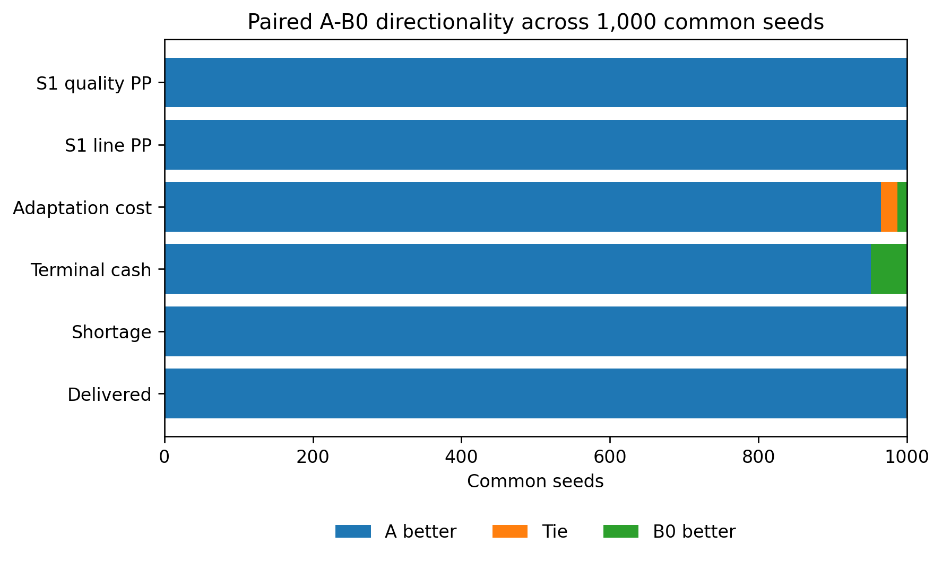
Figure 1. Paired A-B0 directionality across the 1,000 common seeds for six headline outcomes. For lower-is-better outcomes, 'A better' denotes a lower value under A. The figure preserves native outcome direction rather than constructing a composite score.

9.3 Quality events and productive-power preservation
Major field-quality events also separated the regimes. A averaged 0.031 major events per run, with 24 of 1,000 runs experiencing at least one event. B0 averaged 0.719 events, with 415 runs experiencing at least one. The other scalar variants ranged from 0.628 to 0.738 mean events per run; C averaged 0.165. Figure 2 shows the full regime-level incidence distribution.
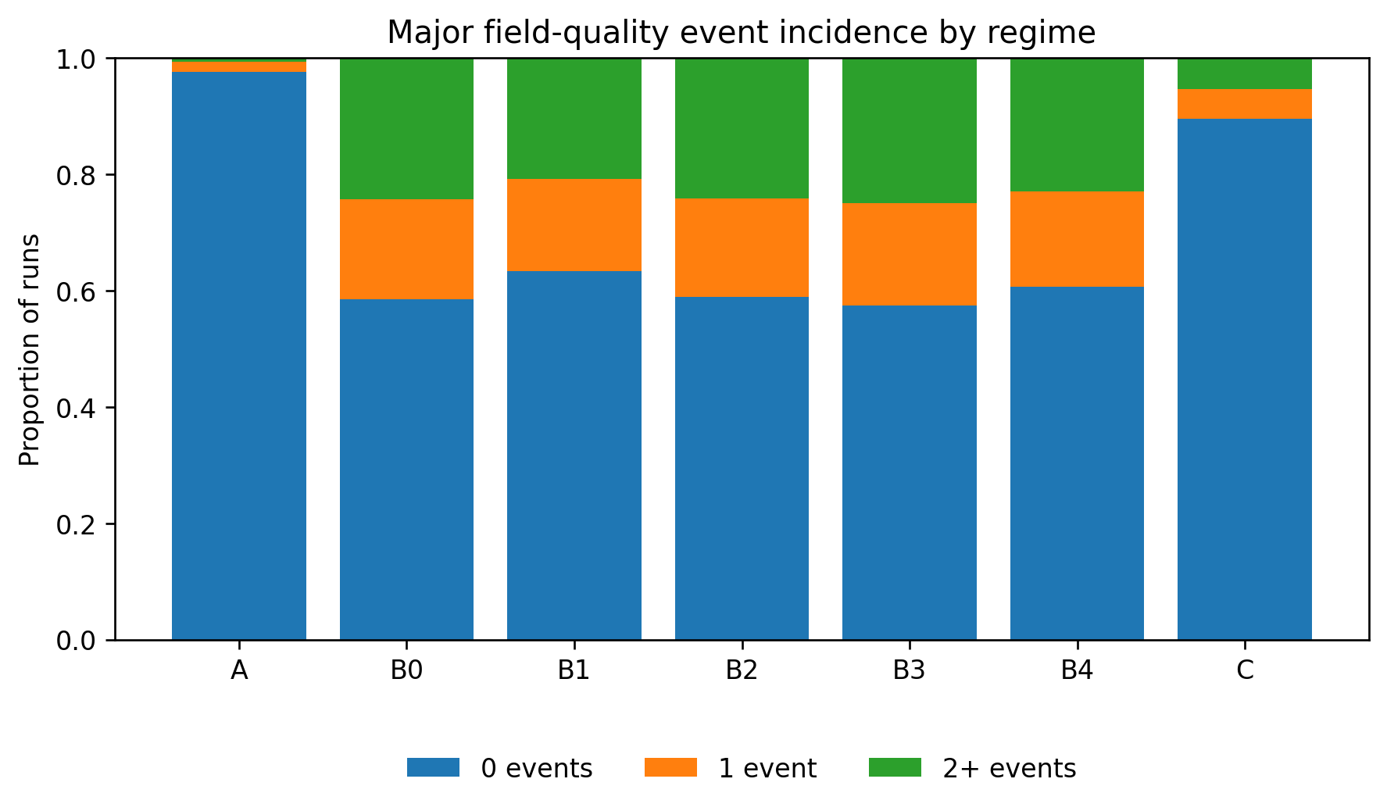
Figure 2. Incidence of major field-quality events across M14 regimes. Each bar partitions the 1,000 runs into zero, one, or at least two major events.
In the paired A-B0 comparison, A had a mean 0.688 fewer major field events per run; A was better on 404 seeds, tied on 589, and worse on 7. At the same time, terminal S1 line PP averaged 85.44 under A versus 50.63 under B0, and terminal S1 quality PP averaged 82.24 versus 37.10. Figure 3 displays the corresponding paired terminal line and quality PP observations.
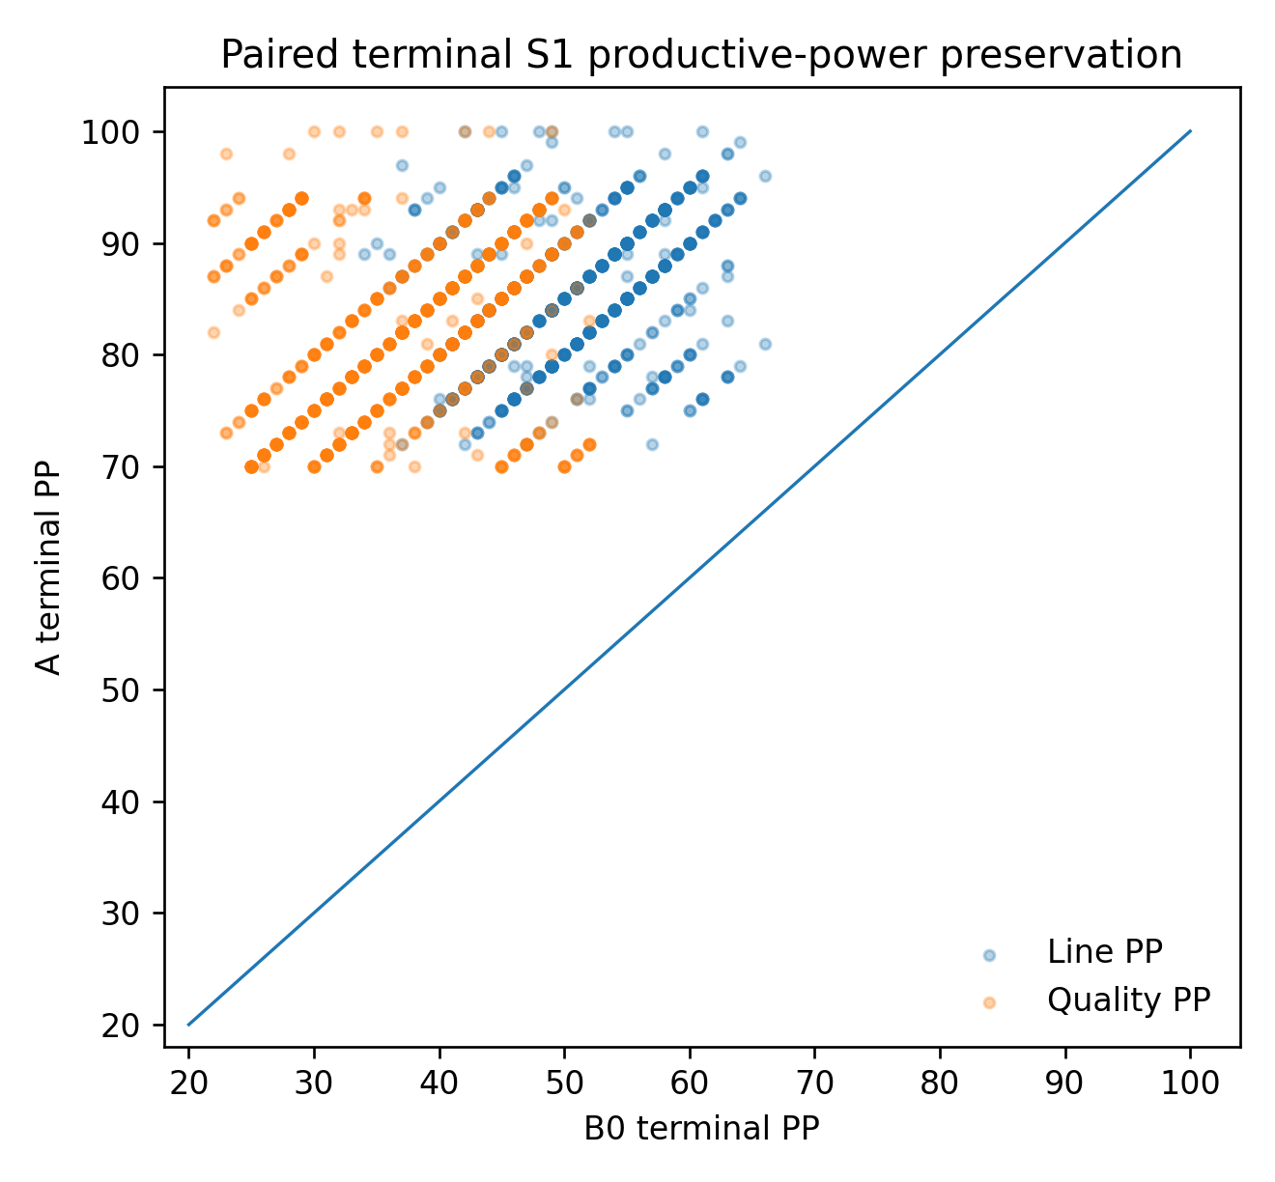
Figure 3. Paired terminal S1 line and quality productive power under A and B0. The diagonal denotes equality; points above the diagonal indicate greater terminal PP under A for the same common seed.

9.4 Customer operations and collapse
Customer business collapse remained rare but the corrected reporting distinguishes collapse from executable termination and end-horizon censoring. A recorded two business collapses, one of them right-censored at period 16. B0, B1, and B3 each recorded four collapses, three right-censored; B2 and B4 each recorded three, two right-censored; C recorded three, two right-censored. Exact matched binary testing does not identify a statistically reliable A-B0 collapse difference at this event rate (business-collapse McNemar p=0.625; family-adjusted p=1.0), so the collapse counts are treated descriptively.
Terminal customer operations PP was also higher under A than B0 by a paired mean of 11.16 points (95% bootstrap CI 10.43 to 11.90). A was better on 688 seeds, tied on 256, and lower on 56.

10. Interpretation

10.1 Aggregate pattern
The M14 ensemble establishes substantial behavioral separation between the frozen PV-PP architecture and the specified comparators. The pattern is not limited to one output variable: A simultaneously delivered more usable product, accumulated less shortage, retained more terminal cash, spent less on adaptation, experienced fewer major field-quality events, and preserved substantially more supplier productive power than the balanced scalar comparator.

10.2 Trace-supported mechanism
Deterministic replay of selected banked common seeds provides process evidence for how some of this separation develops. Each replay reproduced the archived terminal state before ledger details were examined. Because A and B0 are homogeneous population regimes, the examples are coupled multi-agent trajectories rather than isolated treatment effects of one manufacturer's action.
Across three strongly separating examples, A used a broader and earlier sequence of recovery-protective actions: S1 assistance before recovery, alternate S2-capacity reservation, customer renegotiation, production conservation or rationing, transport booking, and financing. B0 often returned repeatedly to S1 assistance after line and quality productive power had already deteriorated substantially. In those paths the B0 trajectory subsequently contained more major field-quality events, lower S1 productive power, and weaker downstream delivery.
Seed 289 illustrates early recovery and diversification. At period 3 A assisted S1 while B0 issued a zero S1 order. By the end of period 4, assisted recovery in A had restored S1 line/quality PP to 89/87, compared with 69/62 under B0, and A had begun reserving S2 capacity. B0 later recorded two major field-quality events and reached zero customer operations PP at the horizon. A finished with customer operations PP 40.
Seed 596 shows a different response sequence. The regimes shared early M actions through period 4, after which A requested customer renegotiation and later used conservation and S2 reservation while B0 repeatedly returned to S1 assistance. B0 accumulated five major field-quality events; A accumulated none. A ended with S1 line/quality PP 82/81 versus 47/36 under B0 and delivered 1052 units versus 787.
Seed 704 provides the clearest alternate-capacity example. At period 4 A reserved 60 units of S2 capacity for five periods while B0 allocated its split-source decision entirely to S1. B0 S1 line/quality PP subsequently declined to 49/34 by period 9 and two major field-quality events occurred in period 12. A ended at 77/73 S1 line/quality PP and delivered 1134 units; B0 ended at 47/33 and delivered 884.

10.3 Boundary case
The trace evidence also contains a useful hard-failure case. In seed 727, both regimes delivered zero units from period 5 onward and both ultimately collapsed. A nevertheless preserved S1 line/quality PP at 76/74 versus 51/39 under B0. The preserved productive capacity was not sufficient to restore delivery once the broader system had entered prolonged financial and downstream collapse. This case rules out an interpretation in which productive-power preservation mechanically guarantees survival.

10.4 Interpretation boundary
Taken together, the traces are consistent with a mechanism in which PV-PP's adequacy, recovery-path, and productive-capacity representation changes the timing and portfolio of protective actions, thereby preserving future productive options in many trajectories. They do not prove that any single action causes the aggregate effect, nor do they show that no scalar architecture could reproduce the same behavior. The mechanism claim is therefore one of trace-consistent architectural behavior within the frozen Asterion system.

11. Limitations
Asterion is a constructed benchmark, not a field experiment. Its world mechanics, horizon, stochastic processes, institutional rules, controller definitions, and scalar comparator family are modeling choices. The primary inference therefore concerns these frozen architectures in this benchmark. The experiment does not establish universal PV-PP superiority or rule out a differently designed scalar, robust, model-predictive, lexicographic, or multi-objective controller.
The 16-period horizon creates right-censoring when a collapse becomes observable only after the final realization. The M14 lineage also includes prospective semantic and implementation corrections, including the M13 customer-exit closure and M14 quality-path repairs. Those corrections strengthen internal validity because they were versioned and made without selecting repairs from M14 outcomes, but they should remain visible to readers.
Finally, the benchmark contains one productive-system topology. Replication across different productive networks, disturbance structures, contractual regimes, information environments, and longer horizons is needed before broader claims about controller classes are warranted.

12. Reproducibility and Artifact Availability
The banked M14 artifact contains the frozen authority/configuration set, source and test files, 1,000 seed-level primary result files, production logs, structural validation output, and banking/validation record. M14 Statistical Analysis Package v0.2 is the publication-facing analysis artifact and contains the flattened 7,000-run dataset, native-unit descriptives, paired comparisons, matched binary tables, family-level multiplicity adjustment, versioned analysis entry point, publication tables, and SHA-256 integrity manifest. The public repository and persistent identifiers will be added after deposition.

13. Conclusion
In Asterion Benchmark V2, the frozen PV-PP controller maintained a markedly different productive-system trajectory from the balanced scalar controller, its four pre-frozen scalar sensitivity variants, and the local deterministic/priority comparator. Across 1,000 common seeds, the PV-PP regime delivered more usable output with less shortage, greater terminal cash, lower adaptation expenditure, fewer major quality events, and substantially greater preservation of supplier productive power. These findings support further testing of PV-PP as a productive-system decision architecture. They should be read as strong benchmark evidence within a frozen constructed environment, not as a universal dominance theorem.

References
Patterson, A., Neumann, S., White, M., & White, A. (2024). Empirical design in reinforcement learning. Journal of Machine Learning Research, 25(318), 1-63.
Kleijnen, J. P. C. (1988). Analyzing simulation experiments with common random numbers. Management Science, 34(1), 65-74. https://doi.org/10.1287/mnsc.34.1.65
Lai, L., Fiaschi, L., Cococcioni, M., & Deb, K. (2023). Pure and mixed lexicographic-paretian many-objective optimization: state of the art. Natural Computing, 22, 227-242. https://doi.org/10.1007/s11047-022-09911-4
Saltık, M. B., Özkan, L., Ludlage, J. H. A., Weiland, S., & Van den Hof, P. M. J. (2018). An outlook on robust model predictive control algorithms: Reflections on performance and computational aspects. Journal of Process Control, 61, 77-102. https://doi.org/10.1016/j.jprocont.2017.10.006
Farina, M., Giulioni, L., & Scattolini, R. (2016). Stochastic linear model predictive control with chance constraints - A review. Journal of Process Control, 44, 53-67. https://doi.org/10.1016/j.jprocont.2016.03.005
Ellis, M., Durand, H., & Christofides, P. D. (2014). A tutorial review of economic model predictive control methods. Journal of Process Control, 24(8), 1156-1178. https://doi.org/10.1016/j.jprocont.2014.03.010
Rockafellar, R. T., & Uryasev, S. (2002). Conditional value-at-risk for general loss distributions. Journal of Banking & Finance, 26(7), 1443-1471. https://doi.org/10.1016/S0378-4266(02)00271-6
Rockafellar, R. T., & Uryasev, S. (2000). Optimization of conditional value-at-risk. The Journal of Risk, 2(3), 21-41. https://doi.org/10.21314/jor.2000.038
Mavrotas, G. (2009). Effective implementation of the epsilon-constraint method in multi-objective mathematical programming problems. Applied Mathematics and Computation, 213(2), 455-465. https://doi.org/10.1016/j.amc.2009.03.037
Hayes, C. F., Rădulescu, R., Bargiacchi, E., et al. (2022). A practical guide to multi-objective reinforcement learning and planning. Autonomous Agents and Multi-Agent Systems, 36, 26. https://doi.org/10.1007/s10458-022-09552-y
Roijers, D. M., Vamplew, P., Whiteson, S., & Dazeley, R. (2013). A survey of multi-objective sequential decision-making. Journal of Artificial Intelligence Research, 48, 67-113. https://doi.org/10.1613/JAIR.3987
Emmerich, M. T. M., & Deutz, A. H. (2018). A tutorial on multiobjective optimization: fundamentals and evolutionary methods. Natural Computing, 17, 585-609. https://doi.org/10.1007/s11047-018-9685-y

